**Name**:…………………………………………………………………...…………….. **Class** …………………………….

**232/3**; **PHYSICS**   **Candidate’s Signature**:………………

**PRACTICAL Date**:…………………………….……

**PAPER 3**

**SEP/OCT 2024**

**TIME: $2\frac{1}{2}$ HRS**

**TRIAL EXAMINATION ~ 2024**

***Kenya Certificate of Secondary Education (K.C.S.E.)***

**INSTRUCTIONS TO CANDIDATES**

* **Write your name and index number in the spaces provided.**
* **Mathematical tables and non-programmable calculators may be used.**
* **This paper consists of TWO questions.**
* **Attempt all the questions in the spaces provided.**
* **ALL working MUST be clearly shown.**

**For Examiners Use**

|  |  |  |
| --- | --- | --- |
| **QUESTIONS** | **MAXIMUM SCORE** | **CANDIDATE’S SCORE** |
| **1A** | **10** |  |
| **B** | **10** |  |
| **2** | **20** |  |
| **TOTAL** | **40** |  |

***This paper consists of 6 printed pages. Candidates should check to ascertain that all pages are printed as indicated and that no questions are missing.***

**Question 1**

You are provided with the following apparatus:

* A metre rule
* Knife edge
* One 50g mass and one 100g mass
* A beaker
* Some thread
* Some water in a beaker
* Liquid L in a beaker
* Tissue paper
* Rubber cork/bung.
* Vernier calipers.
* Electronic beam balance (to be shared)

**PART A**

**Proceed as follows:**

1. Using a vernier caliper, measure the lengths D, d, and h as shown in **figure 2** of the rubber cork/bung**.**

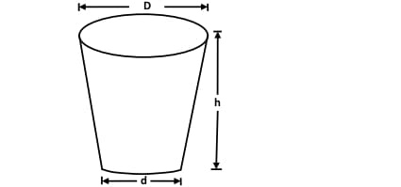

D = ………………………… cm ………………………… m

d = ………………………… cm ………………………… m

h = ………………………… cm ………………………….. m (3 marks)

b) (i) Measure the mass, M of the rubber bung using the beam balance.

**M = ....................................................... kg** (1 mark)

**c)** Given that $Q= \frac{D+d}{4}$ determine the value of Q (2 marks)

…………………………………………………………………………………………………………………………………………………………………………………………………………………………………………………………………………………………………………………………………………………………………………………………………………………………………………………………

d) Determine the value of r given that; $πrQ^{2}=\frac{m}{h}$ (2 marks)

e) What is the significance of r. (1 mark)

………………………………………………………………………………………………….

**PART B**

Proceed as follows:

1. Balance the metre rule on the knife edge and record the reading of the balance point.

𝐵𝑎𝑙𝑎𝑛𝑐𝑒 𝑝𝑜𝑖𝑛𝑡= ..........................................cm mark. (1 mark)

*For the rest of this experiment the knife edge must be placed at this position*

1. Set up the apparatus as shown in the figure below.

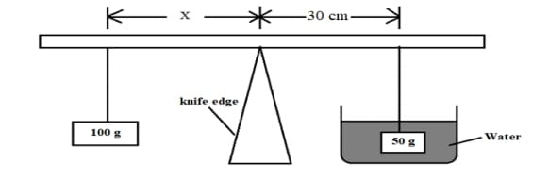

1. Use the thread provided to hang the masses such that the positions of support can be adjusted. The balance is attained by adjusting the position of the 100g mass.

Note that the distances X is measured from the knife edge and the 50g mass is fully submerged in the water.

1. Record the value of X.

𝑿=..........................................cm (1 mark)

1. Apply the principle of moments to determine the weight Ww of the 50 g mass in water. (2 marks)

………………………………………………………………………………………………………………………………………………………………………………………………………………………………………………………………………………………………………………………

1. Given that $r=W-W_{w}$; where W is the real weight; determine the value of r. (1 mark)

………………………………………………………………………………………………………………………………………………………………………………………………………………………………………………………………………………………………………………………

1. Remove the 50 g mass from the water and dry it using tissue paper.
2. Maintaining the distance of 30cm in step(b), now balance the metre rule when the 50g mass is fully submerged in the liquid L.

Record the value of the distance X.

𝑋=....................................cm (1 mark)

1. Apply the principle of moments to determine the weight WL of the 50g mass in the liquid.

(2marks)

………………………………………………………………………………………………………………………………………………………………………………………………………………………………………………………………………………………

1. Determine the value of S, if $S=W-W_{L}$ with W as real weight. (1 mark)

…………………………………………………………………………………………………………………………………………………………………………………………

1. Given that $k=\frac{S}{r}$ Determine the value of k. (1 mark)

………………………………………………………………………………………………………………………………………………………………………………………………………………………………………………………………………………………

1. Suggest what k represents. (1 mark)

……………………………………………………………….

**Question 2**

You are provided with the following:

* 2 new dry cells size D
* Cell holder.
* Milliammeter ( 0-1 mA),
* 8 connecting wires (4 with at least 1 crocodile clip).
* Resistor R (3000 Ω)
* Capacitor C (2200μF)
* A switch

**Proceed as follows:**

1. Connect the circuit as shown in the **figure** below, where **P** and **Q** are crocodile clips.

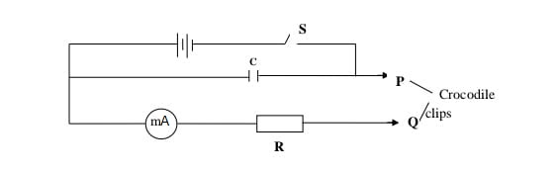

1. Close the switch **S**
2. Name the process which takes place when the switch **S** is closed

……………………………………………………………. (1 mark)

1. Connect the crocodile clips P and Q. Observe and record the highest reading of the milliammeter **Io (** This is the current at **t**= 0)

Io=………………………………………………………… mA (1 mark)

1. With the milliammeter showing the maximum value of current **I**o, open the switch S and start the stop watch simultaneously. Stop the stop watch when the current has dropped from Io to 0.5 mA. Read and record in the table below the time taken.set the stop watch and close the switch. Repeat the procedure in (e) to measure and record the time taken for the current to drop from **Io** to each of the other values shown in the table below. (7 marks)

|  |  |  |  |  |  |
| --- | --- | --- | --- | --- | --- |
| **Current, I (mA)** | **0.5** | **0.4** | **0.3** | **0.2** | **0.1** |
| **Time, t (s)** |  |  |  |  |  |
| **Log I** |  |  |  |  |  |
| **Log t** |  |  |  |  |  |

1. Plot a graph of **log t** against **log I** (5 marks)



1. Find the slope, S of your graph. (3 marks)

………………………………………………………………………………………………………………………………………………………………………………………………………………………………………………………………………………………………………………………………………………………………………………………………

1. The equation connecting I and t is given as $n log{I}+\log{ t}=Q$; find the value of constants n and Q. (3 marks)

………………………………………………………………………………………………………………………………………………………………………………………………………………………………………………………………………………………………